Instruction Manual
LED Dimmer Switch
Item no. 701DC
Functions
            - The device dims your light to save energy. It also provides a comfortable ambiance anytime you wish.
            - Can be used for incandescent, halogen lighting and majority of LED lighting.

- Installation
            - IMPORTANT: ensure the electric supply is cut off before installing.
            - Connect the wires to the dimmer switch according to below diagrams.
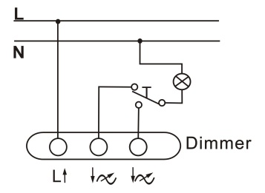
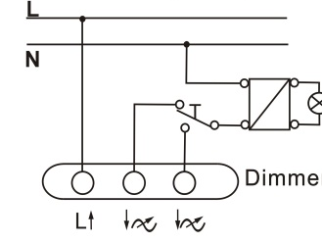
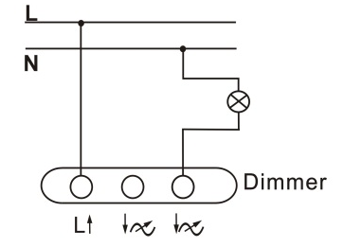
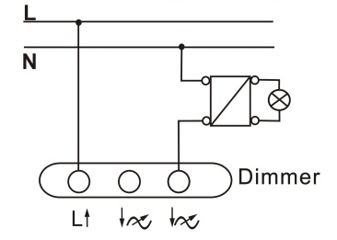
            - Mount the dimmer switch onto the wall.

- Caution
            - DO NOT disconnect the lamps while the dimmer is on
            - The input voltage should be conformed to below specifications
            - The dimmer is NOT suitable for all fluorescent lighting, dimmable LED lighting

- Specification
Power rating: 230V~, 50Hz
Wattage: incandescent/halogen lighting 30-200W
LV-halogen lighting with electronic step-down converter 30-200W
specified LED lighting 3-24W

Correct disposal of the product
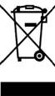
Within the European Union, this symbol indicates that the products must not be disposed in the household waste. Devices contain valuable recyclable materials that should be recycled for reuse and uncontrolled waste disposal may cause harm to the environment and human health. Please dispose the old products via suitable collection systems or send the unit to the office where you bought it. This will make the product recycling.

Manufacturer :

Manufacturer: Zhejiang Everflourish Electrical Co., Ltd.
Adress: Renjiu Village, Wuxiang Town,Yinzhou,Ningbo 315111,P.R.China

